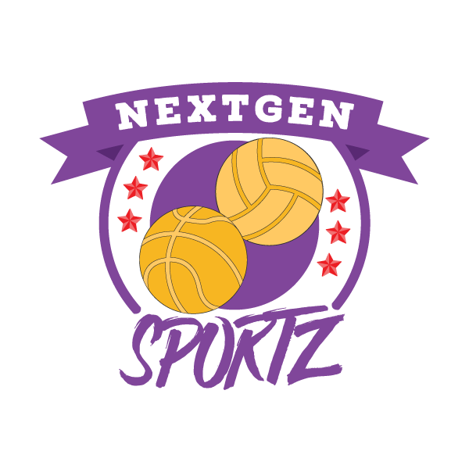
NextGen Sportz Association

Position Title: Volunteer Duration: Summer
Location: Richmond Hill Salary: N/A

We are a non-for-profit organization that believes all youth deserve the opportunity to reach their full potential in sports. We exist to level the playing field for the youth of our city by addressing the financial barriers and providing direct access to high, quality coaches.

Volunteers are responsible for:
- Assist staff with implementing age appropriate fitness, weight and skill development training programs.

- Assist with the leading and/or supervising of the practices, games and events.

- Report all accidents/incidents and program concerns to the lead Staff/Coordinator/Director(s) on-site.

- Adhere to all program rules, policies, and procedures.

- Notify the lead Staff/Coordinator/Director(s) when any purchases of equipment and/or supplies are needed

- Assist with making sure that all equipment and supplies are organized and stored properly at the end of the program.

- Actively participate in fundraising activities to help improve all programs.

- Actively participate in NextGen Sportz programs ie. sport camps, summer programs, etc.

- Actively participate in a plan to enhance public relations for the NextGen Sportz Association.

- Attend instructional clinics to remain up to date in training/coaching. (not mandatory but an asset.

- Perform all other duties as assigned.

Additional Expectations:
- Must be patient with children and youth.

- Must be organized, dependable and able to motivate others.

- Must have strong interpersonal and communication skills.

- Ability to work independently, with others and with a wide variety of ages and demographic groups.

- Ability to work with a diverse team in a fast-paced environment.

- Prior sports experience is an asset..

Qualifications and Requirements:
- Successfully complete and pass a vulnerable sector screen check and any other requirements needed.

- Demonstrate organizational skills.

- Must be comfortable working with youth ages 9+.

- Must be at least 14 years of age.

- First Aid and/or CPR certified (not required but an asset)

How to apply:
Email your resume and cover letter to nextgensportz@gmail.com please reference the job title in the subject line and ensure contact name and e-mail are provided.

