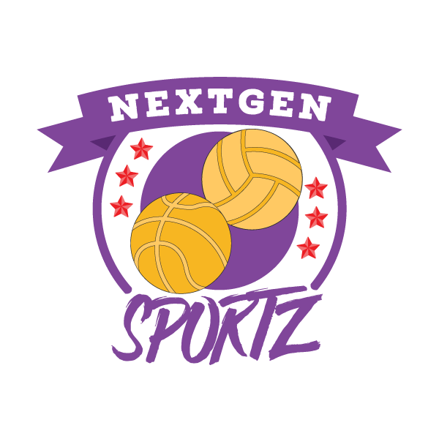
NextGen Sportz Association

Position Title: Sport Instructor (SI) Duration: Summer
Location: Richmond Hill Salary: $16.00/hr

We are a non-for-profit organization that believes all youth deserve the opportunity to reach their full potential in sports. We exist to level the playing field for the youth of our city by addressing the financial barriers and providing direct access to high, quality coaches.

Sport Instructor (SI) is responsible for:
- In consultation with the Program Coordinator the incumbent is responsible for planning and implementing the fitness and weight training, skill training as well as scheduling for the beach programs that are age appropriate.

- Organizes and leads the instructional beach volleyball program.

- Complete any accidents/incidents reports and documents program concerns that arise and submit them to the Program Coordinator.

- Implement and adhere to all program rules, policies, and procedures.

- Ensure that staff, volunteers and participants are following program rules, policies and procedures.

- Notify the Program Coordinator when any purchases of equipment and/or supplies are needed.

- Implement and enforce that all equipment and supplies are put away and stored properly at the end of the program.

- Actively participate in fundraising activities to help improve the summer beach volleyball programs.

- Attend instructional clinics to remain up to date in training/coaching.

- Perform all other duties as assigned.

Additional Expectations:
- Must be patient with children and youth.

- Must be organized, dependable and able to motivate others.

- Must have strong interpersonal and communication skills.

- Ability to work independently, with others and with a wide variety of ages and demographic groups.

- Ability to work with a diverse team in a fast-paced environment.

- Must have some knowledge, experience or expertise in Volleyball.

Qualifications and Requirements:
- At least Level 1 trained in Volleyball.

- Successfully complete and pass a vulnerable sector screen check and any other requirements needed.

- Demonstrate organizational skills.

- Comfortable working with youth ages 9+.

- Must be at least 18 years of age.

- Must be First Aid and CPR certified. (must show proof)

How to apply
Email your resume and cover letter to nextgensportz@gmail.com please reference the job title in the subject line and ensure contact name and e-mail are provided.

